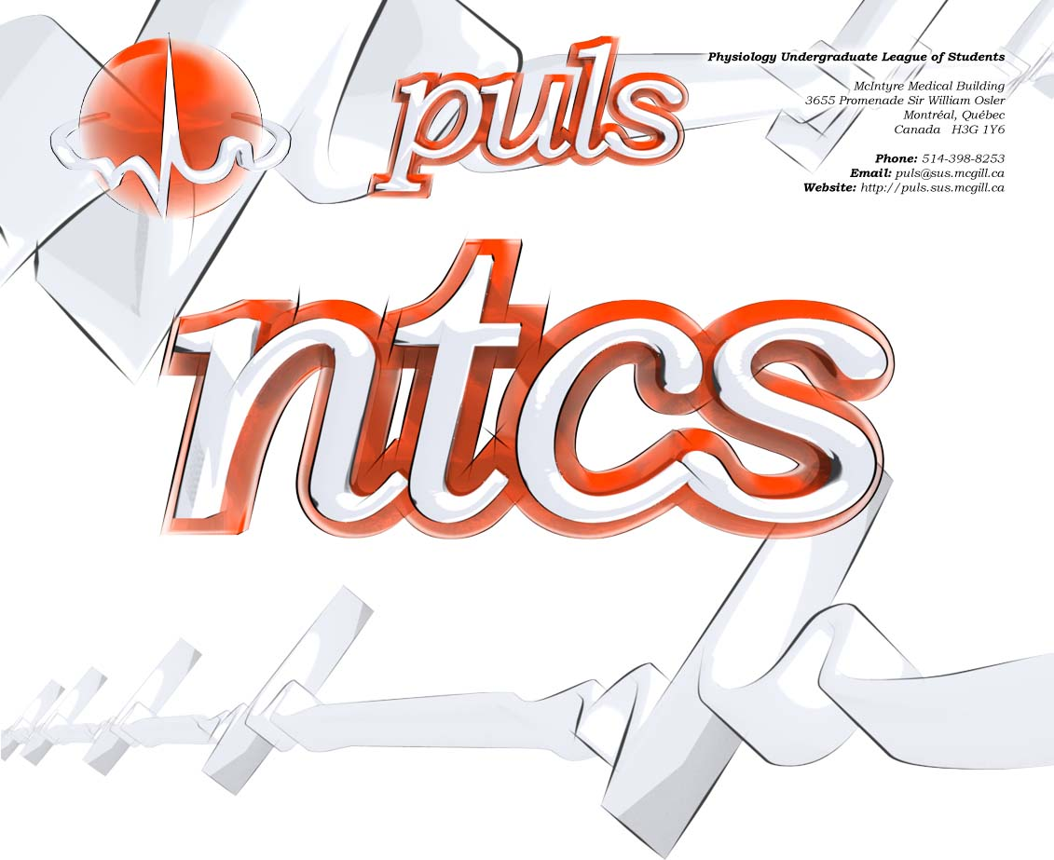
phgy311
lecture #: | date: | professor:
31 | Nov. 29, 2006 | Dr. Farookhi
32 | Dec. 1, 2006 | Dr. Farookhi
announcements:

Edited By: Steph Rolin
Do Not Redistribute.
set #11
PHGY 311 – Lecture 31 November 29, 2006
Writer: Ana Coutinho Dr. Farookhi

- Course evaluations will be up December 4 to December 18th

QUESTION FROM STUDENT
- Will menopause be delayed in the Kung? Or in a woman who has had one ovary removed? Anyone who is not ovulating monthly?
    - There would be compensation for the hormones, but not the germ cells
      - If you don’t have germ cells, then you don’t have follicles
      - Hormonal and germ cell exhaustion occurs at around the same time, so both seem to decline together
- Consider birth control: this stops ovulation, but you still have menopause occurring at the same time.
    - This is always true: if you disrupt menstrual cyclicity, you will always have menopause occurring at the same time

- Recall the primordial follicle pool: there was spontaneous development that was dependent on the number
    - Once they begin to develop, they can
      - Ovulate
      - Stop
    - Therefore by changing the population, you are only changing the kick-off
      - Everything else will stay identical, only the follicular pool is changing
        - The eggs are still developing, but through the suppression of LH and FSH, they do not develop to the point where they would be ovulated and so they die
        - They would die without the stimulation of GnRH, which releases LH and FSH

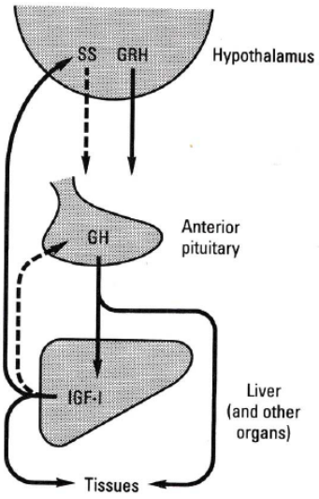
- Therefore, the lack of ovulation will NOT influence the time of initiation of menopause because it is controlled by a separate process

GROWTH
- Two growth-related hormones are released from the hypothalamus.
    - Somatostatin (SS): inhibits GH secretion
      - GPCR is negatively coupled to AC
    - Somatoliberin (GRH, GHRH): stimulates GH release
      - Impinges on somatotrophins in anterior pituitary to secrete GH
        - GPCR
  - The anterior pituitary releases GH.
    - GH is a cytokine (related to Prolactin)
    - Species specific
      - Recombinant GH molecules can now be used to stimulate growth between species
    - It stimulates the releases insulin-like GF-1 from liver and other tissues.
      - IGF-1 is the hormone that feedbacks to the hypothalamus and anterior pituitary to modulate somatostatin, somatoliberin, and growth hormone.
        - Peptide
        - PTK receptor
GH ACTIONS
- GH is released in a pulsatile fashion.
    - Diurnal rhythm: hourly, down and up
      - If you map back the rhythm to the actions of the hypothalamus, somatoliberin will mirror the peaks of GH, whereas somatostatin will peak during the lows of GH

  - The promotion of growth is indirect and is through IGF (somatomedin)
    - GH acts on the liver and causes the release of somatomedins. This is responsible for growth, fat cells, microprotein synthesis, bone growth, cartilage growth
    - Somatomedins are mediating the growth activities of GH
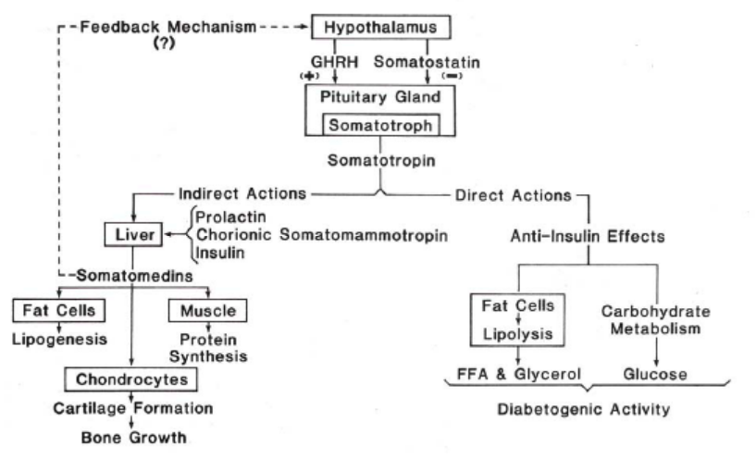
  - GH also has a direct action, which are its anti-insulin effects.
    - Causes lipolysis and carbohydrate metabolism.

IGF FAMILY
- The IGF family consists of molecules that structurally resemble insulin.
    - B-chain and A-chain form disulfide bridges. The C portion is cleaved, which leaves two subunits linked by disulfide (but they are made as a single, linear peptide)
      - IGF1, IGF2 and relaxin all follow this pattern

- They signal through receptors that look like insulin receptor
    - Dimeric
    - Tyrosine kinase activity is stimulated by ligand binding
    - Move through adaptors to activates downstream effects to stimulate growth (in cell-specific manner)
      - Moves through ISR-1, IRS-2 (Insulin Receptor Substrate)

- To activate growth, one must activate cell proliferation
    - This involves IRKs, MEKs, etc
      - The main actions are to affect the cell cycle to cause cell proliferation.
      - Also turn on transcription factors to cause differentiation
- Insulin vs. IGF-I and IGF-II.
    - Insulin is better at promoting metabolic effects in insulin target tissues,
    - IGF-I and IGF-II are better at stimulating cell proliferation.
- IGFs have 2 receptors.
    - IGF-I—ligand-dependent, tyrosine kinase. Similar to insulin receptor, but higher affinity for IGF-I and IGF-II,
    - IGF-II—different structure. Does not bind insulin and has a higher affinity for IGF-II.
  - IGF-1 receptor looks a lot like insulin receptor
    - The two ligands can activate opposing receptors in high concentrations, but with low affinity

OVERVIEW OF SIGNALLING PATHWAY
- The hypothalamus can release GHRH and somatostatin
    - GHRH stimulates the release of GH from the anterior pituitary.
    - Somatostatin inhibits the release of GH.
- GH is released from the anterior pituitary
    - There is binding protein in circulation to protect GH from degradation and it is responsible for delivery to target organs
    - It is unknown whether GH directly interacts with receptor in liver or in context of GH binding protein
      - Bound vs. unbound—appears you are able to get stimulation in both cases
  - Signal transduction:
    - GH is a cytokine, so it uses the JAK, STAT pathway
      - Leads to transcription: IGF-1, IGF binding proteins
        - Shipped out of target cell as complex with IGF-1, IGF binding protein and ALS [acid labile substrate]
  - Complex is released to the circulation and move to target organs
  - IGF1 receptors are in bone
    - Release of IGF-1 through proteases
      - Localized action of IGF-1—interaction with receptors and transduction of signal

BINDING PROTEINS
- There are 6 IGF binding proteins
    - Don’t need to know what they do
    - Know that they are involved with binding IGF and as long as IGF is bound to binding protein, it is inactive
      - Need to digest IGFBP to activate IGF such that it can interact with its receptor

GROWTH STIMULATION THROUGH GROWTH HORMONE
- Growth stimulation occurs through IGFs
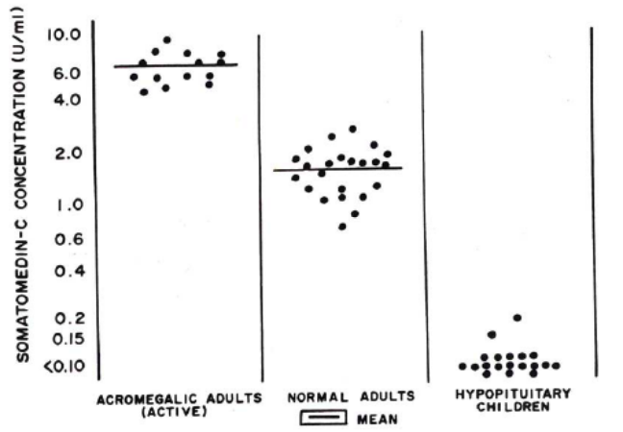
    - See graph
    - The middle column is that of a normal male and shows the amount of somatomedin C released
    - If there is a tumor in the somtaotrophs of the pituitary or regulation in the hypothalamus goes awry, there will be an excess amount of GH hormone released and therefore IGF-1 secretion, resulting in acromegaly
      - End up being extremely tall
    - Mutations along the pathway can cause a decrease in the amount of GH and IGF-1 hormone released
      - Growth is underdeveloped
      - Can be treated with GH-replacement therapy today

KNOCK-OUT (KO) STUDIES
- IGF-1 KO:
    - There is no IGF-1 made. Ever
      - Results in small pups (60% of weight of the normal)
  - IGF-2 KO:
    - There is no IGF-2 made. Ever
      - Results in small pups and small placenta
        - Small placenta most likely gives rise to the small pups
        - Intrauterine growth retardation
  - IGF-1 AND IGF-2 KO:
    - Results in pups born at 30% of weight and postnatal death
      - This illustrates the point that maturation of tissues is not occurring and that during development in utero, they were using a different factor (because they survived)
      - Once it is on its own, it can’t survive due to lack of maturation of the systems
- IGF-1 receptor KO:
    - Leads to post-natal death
    - Therefore, there is no ligand binding, so although mom is helping, it’s not enough because there is no action
    - But how do we still get a pup born?
      - Ligand must be working through the insulin receptor, which works, but is not as effective
  - Examine the last two knockout families, while keeping in mind that the mother can provide ligand to her child and IGF can bind to insulin receptors to stimulate some growth in utero, although it can not be sustained after birth
    - IGF-1 receptor + IGF-1
    - IGF-1 receptor + IGF-2
- GH KO:
    - Normal size at birth, but growth arrested
    - GH is not needed in the fetus
      - Not being provided by mother, otherwise no problem would exist in the case of the IGF knockouts.
    - GH feedback loop in the fetus does not exist
      - IGF secretion is independent of this loop; IGF is produced directly, without being stimulated by IGF
    - Once it is born, the loop kicks in and does not work
- Transgenics:
    - IGF-1 transgenic: has too much IGF-1 and is larger than normal
    - IGF-2 transgenic: has too much IGF-2 and does not grow faster
      - Illustrates the fact that IGF-1 is the MAIN effector of growth

IMPRINTING
- Process which allows cells, and genetic machinery, who contributed the particular allele of the particular gene. It is a way of determining if the allele was donated by the mother or the father
    - Process occurs due to methylation

  - In IGF-II
    - IGF2: not methylated in father, but methylated in mom
      - Therefore, IGF-2 comes from the father
    - IGF2 receptor: not methylated in mother, but methylated in father
      - Therefore, IGF-2 receptor comes from the mother

- Reason is not understood
  - Hypothesis: since IGF2 stimulates growth, if the fetus is healthy in utero, there is the probability of success of propagating a healthy individual
        - Males want to ensure the propagation of his genes, so they want lots of IGF2 to create healthy offspring
        - Females want to make sure that the baby doesn’t grow too big that they can’t have birth, so they control the response to IFG2 by limiting the number of receptors
      - Reflects evolution

OTHER GROWTH PROMOTERS/INHIBITORS
- Look them up in the books and learn their target organs and what they do
    - Fibroblast growth factors [organ growth, esp. long bones]
    - Epidermal growth factors [ubiquitous, many tissues]
    - PDGF [angiogenesis]
    - VEGF [angiogenesis]
    - NGF
    - TGFB [inhibitory generally]
    - TNF [apoptosis]

DIRECT ACTIONS OF GH
- Direct actions of GH are similar to anti-insulin effects
    - GH will act directly on:
      - Fat cells
      - Liver to cause release of carbohydrates
        - Increased blood sugar

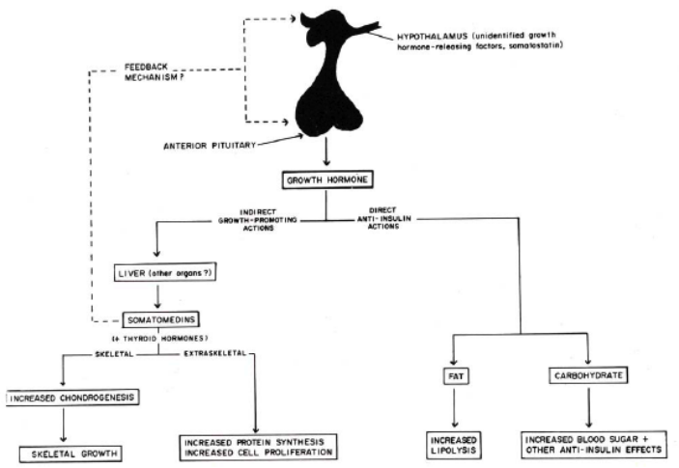
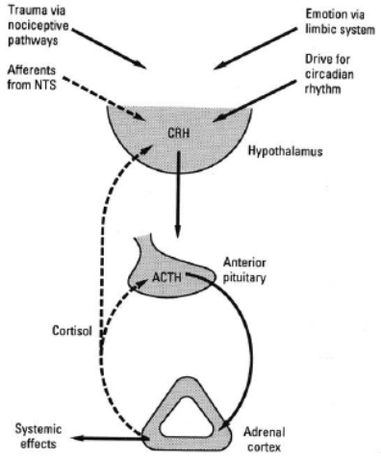
  - So overall, GH causes indirect growth promotion, and direct production of energy for the growing individual and the proliferation of cells

ADRENAL GLAND
- The adrenal gland is affected by actions of the hypothalamus and anterior pituitary.
    - Hypothalamus releases Cortiotropic Releasing Hormone (CRH)
    - Anterior Pituitary releases ACTH in response to CRH.
      - ACTH is a prohormone and is processed in secretion granules before release
    - ACTH acts on the cortex of the Adrenal Gland.
THE ADRENAL GLAND
    - Medulla:
      - From the sympathetic ganglia, which comes from the neural crest, which is neural tissue
    - Cortex:
      - Endocrine section
      - Has mesodermal origin
      - In response to ACTH, will synthesis and secrete a number of hormones, but the most important is cortisol, which is the feedback hormone [also produces aldosterone and androgens]
        - Feedbacks to the hypothalamus and the anterior pituitary
      - 3 layers:
        - Zona Glomerulosa
        - Zona Fasciculate
        - Zona Reticularis

THE HORMONES
- Cortisol
    - Stimulated by ACTH
    - This is the only hormone produced that has an effect on the feedback system
  - Androgens
    - Stimulated by ACTH
  - Aldosertone
    - Stimulated by renin-angiotensin system

CHOLESTEROL
- Is the basis for the production of the above hormones
  - Steroid hormone synthesis requires:
    - 17 alpha-hydroxylase for androgens
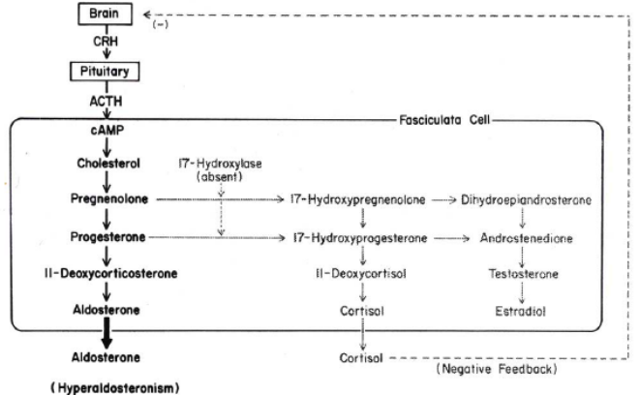
    - 21-hydroxylase for glucocorticoids
    - 11-beta hydroxylase and 18-hydrogenase for aldosterone

- 17 Alpha Hydroxylase Deficiency
    - Not able to produce androgens or glucocorticoids
      - Build up of aldosterone
    - Since no corstisol, no feedback to stop secretion of ACTH

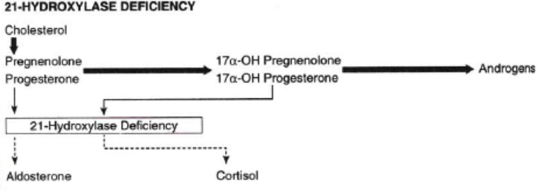
  - 21 Hydroxylase Deficiency
    - Not able to produce glucocorticoids, so there is a build up of androgens
    - If in a female: will have masculinization of phenotypic expression

TARGET TISSUES OF GLUCOCORTICOIDS
  - Multiple target tissues through a intracellular receptor or ligand-dependent transcription factor to target transcription
    - Muscle: break down of protein to amino acids
    - Lymphoid: block upper T cells
    - Connective tissue break down to release amino acids
    - Adipose tissue break down to fatty acids
    - Net result: increase in amino acids and fatty acids
      - Gives rise to gluconeogensis in the liver
        - Glucose secretion to the blood

- Glucocorticoids also have anti-insulin effects

- Look a the table in notes: It tells you what happens if you have cortisol deficiency or excess in response to a number of homeostatic physiological factors

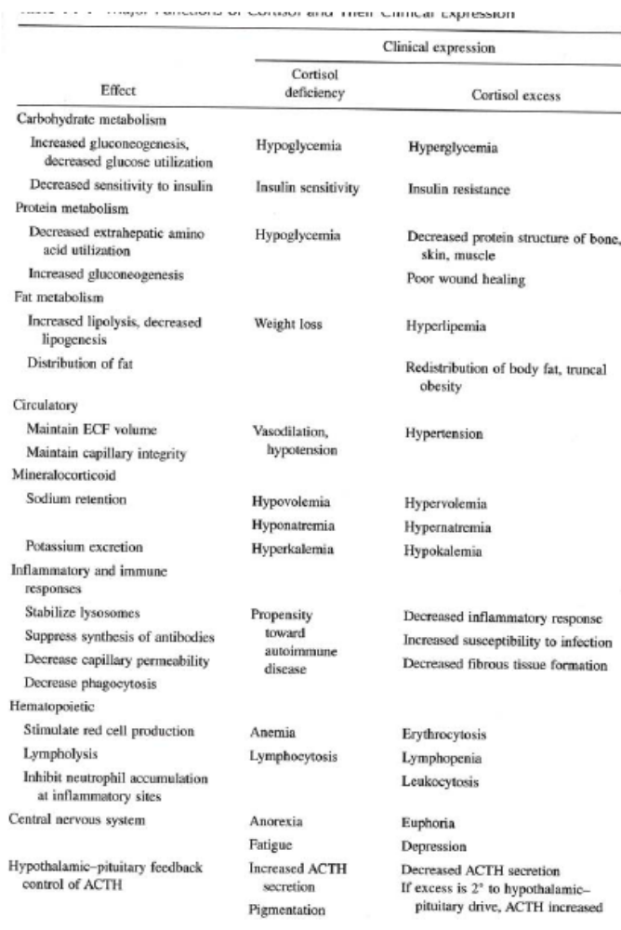

PHGY 311 – Lecture 32 December 1, 2006
Writer: Ana Coutinho Dr. Farookhi

IMPORTANT INFORMATION
- Course Evaluations: Please fill it out on WebCT
  - Farookhi will be holding his office hours until the final

- Any information that is not covered is still testable material!!!
    - Read the textbook and look over the slides

- Exam:
    - Approximately 1 hour
    - Six questions
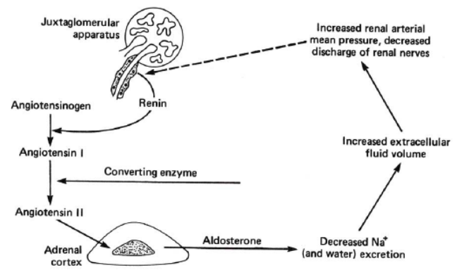
ADRENAL GLAND
- Mineralocorticoids [Aldosterone]
    - Is a steroid hormone produced by the adrenal glands

    - Multiple organs involved: kidney, liver, lung, blood, adrenal
      - Remember: if you block enzymes on the synthesis pathway, you will block production of downstream hormones and build-up upstream hormones

- Aldosterone is working to increase all of the players involved with sodium reabsorption, the sodium channels and ATPase. Aldosterone will upregulate these proteins and/or stimulate them, with the end result that the entire system is boosted up.
    - Aldosterone targets the distal tubules of the kidney, where it turns on Na⁺/K⁺ pumps and Na⁺/H⁺ transporters to allow Na⁺ re-uptake from the fluid in the tubules
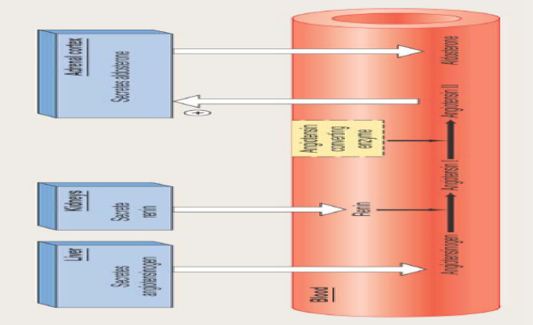

- Aldosterone comes from the activation of the renin-angiotensin system. The kidneys secrete renin, which converts angiotensinogen from the liver into angiotensin I.
- In the lungs, angiotensin I is further converted, into angiotensin II, by ACE. Angiotensin II then stimulates the secretion of aldosterone from the adrenal cortex, which makes its way to the kidneys.

- There are three different pathways to activate the renin-angiotensin system. All of them are initiated by a drop in plasma volume, for whatever reason.
    - A drop in plasma volume increases the activity of renal sympathetic nerves. This leads to the stimulation of juxtaglomerular cells to increase renin secretion.

    - Also, low plasma volume causes low arterial BP. This has a direct effect on the afferent arterioles as there is less stretch of the arterioles. This information is passed onto the juxtaglomerular cells and they increase renin secretion.

    - If you have low plasma volume, this decreases GFR, which decreases flow to the macula densa cells. As a result, the macula densa cells are receiving less NaCl, which they sense and consequently send a signal to the juxtaglomerular cells to increase renin secretion.

- As volume increases/blood pressure increases, the renin system is turned off by lack of stimulation of the macula densa

- Overview:
    - Note: ACTH is stimulating the substrate, increasing aldosterone production
      - Adds a second level of control (ACTH and angiotensin II)

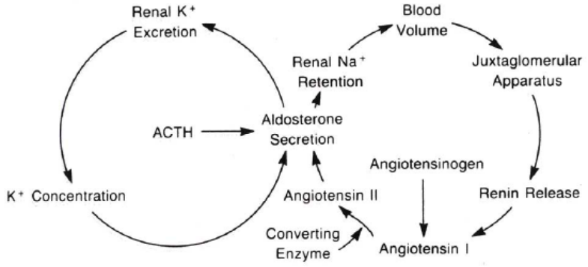

- Glucocorticoid-Mineralocorticoid Dilemma:
    - The mineralocorticoid receptor [intracellular] binds cortisol [glucocorticoid] with the same affinity as aldosterone. In addition, circulating cortisol concentrations are always 100 times greater than aldosterone.
      - K_{D} value is approximately the same, 10⁻⁹ M

    - If cortisol could bind to the aldosterone receptors, then this would elicit the same effects as hyperaldosteronism. However, the receptor does not normally bind to cortisol, as there is an intracellular enzyme, 11-beta HSD, which inactivates cortisol as soon as it enters aoldosterone’s target cells.
      - Cortisol is converted to cortisone, which cannot bind to the mineralocorticoid receptor.

- Licorice Toxicity: Licorice inactivates 11-beta HSD, which normally prevents cortisol from binding to the aldosterone receptors. In one case, a 70-year old man ate 150-250g of licorice a day for 4-5 years. As a result, cortisol could bind to the aldosterone receptor and this man had hypokalemia, hypernatremia, and hypertension.

- Therefore, as long as you have 11-beta-HSD, cortisol will be converted to cortisone in aldosterone target cells. So, the binding affinity problem is not normally a big deal, unless you somehow deactivate it (i.e. with licorice poisoning)

ADDISON’S DISEASE
- Addison’s disease is also called adrenal insufficiency or hypocortisolism. It occurs when the adrenal glands don’t produce enough cortisol. Sometimes Addison’s disease also involves hypoaldosterone.
  - Recall: Glucocorticoids influence the body’s ability to convert food (fuel) into energy, as well as playing a role in the inflammatory response. Mineralocorticoids maintain the potassium-sodium-water balance, and regulate BP.

- Addison’s Disease is characterized by weakness, increased pigmentation, weight loss, hypotension, hypoglycemia
  - Increased pigmentation: making too much POMC, which when clipped, will contain the MSH hormone, which increases melanin in the skin
  - Weight loss: due to a break down of muscle and fat to provide energy
  - Hypoglycemia: cortisol increases gluconeogenesis to provide energy

- Primary Addison’s occurs when the cortex is damaged and doesn’t produce enough hormone. This may occur as part of an autoimmune response.
  - ACTH levels are increased, but there is a diminished response from the adrenal cortex.
- Secondary Addison’s occurs if the pituitary is diseased. Since the pituitary makes ACTH, which stimulates the production of adrenal hormones. Too little ACTH leads to low production of adrenal hormones, even though the adrenal glands aren’t damaged.
  - ACTH levels are low.

CUSHING’S DISEASE
- Cushing’s disease refers to hypercortisolism due to excess ACTH.
  - Cushing’s syndrome refers to excess cortisol resulting from any cause.

- Cushing’s disease is characterized by obesity, hypertension, hyperglycemia, hirsutism [hairiness], occasionally hyperpigmentation
      - Obesity: modulated by glucocorticoids
        - May be an indirect mechanism because the high hormone levels release excess glucose, which will release excess insulin, which will cause an increase in weight
      - Hirsutism: excess androgen
      - Hyperpigmentation; again, as a result of high ACTH levels if secondary stimulation [i.e. cortisol secretion is due to high ACTH secretion]

CONN’S SYNDROME
- Conn’s syndrome occurs when there is a disturbance in salt-water balance. It is usually caused by a tumor of the adrenal glands, leading to excess aldosterone secretion
- Conn’s syndrome is characterized by hypokalemia, hypernatremia, and hypertension. It occurs because there is too much aldosterone.

CALCIUM
- Calcium is used in:
    - Structural integrity of skeleton [bone]
    - Cellular enzymatic process
    - Stimulus-secretion coupling
      - Discharge of secretion vesicles [fusion]
        - In response to an action potential or hormone
    - Muscle contraction
    - Blood coagulation cascade

- Blood calcium levels must be tight controlled. It is regulated by three hormones.
    - Parathyroid Hormone (PTH), which raises calcium levels.
      - This is the most important of the three.
    - Vitamin D, which raises calcium intake from the GIT.
      - Acts on the GIT to absorb calcium; this is the most important source of calcium.
    - Calcitonin, which lowers calcium levels.
      - Calcitonin is not essential for life, and there is no clinical consequences of calcitonin deficiency or excess.

- The hormones are secreted and act as described in the table:
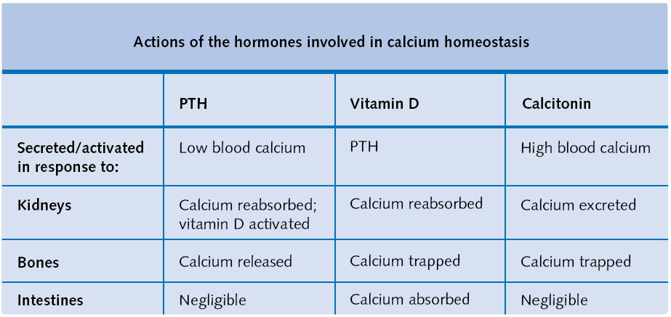
    - As we can see, there are three sources of calcium: kidneys, bones, and from the GIT. Each hormone acts on these three sites to regulate calcium.

- PTH is released when Ca²⁺ receptors on the PT gland sense that the calcium level is too low.
    - This is a GPCR. It activates PLC, which gives rise to PTH secretion.
    - There is an inhibition of adenylate cyclase.
- PTH and PTHRP
    - Found that individuals who had solid tumors were having bone loss as well. Suspected that from this tumor, there must be something that had PTH-like activity.
      - Now called PTH-related protein [PTHRP]
        - Also made by humans in a number of tissues, such as the mammary gland, and it is transmitted in milk during lactation
    - Both PTH and PTHRP share a short segment at the beginning that is virtually identical
      - The first 14 or so amino acids show considerable homology
      - Remaining portion of PTHRP has other functions, although unknown
    - Both PTH and PTHRP can bind to receptor with equal affinity
      - Proves that: all you need to bind is the first 14 amino acids of PTH or PTHRP to elicit cascade activity
  - Intestine and bone mechanisms require 1, 25-(OH)₂D₃ [vitamin D]
    - Need two signals to get any effect
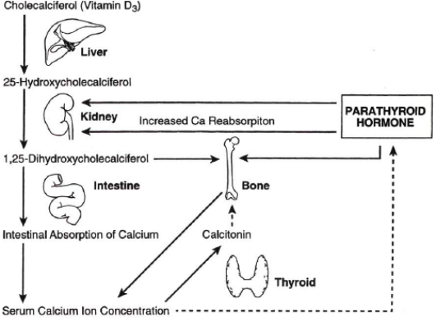
VITAMIN D
  - Cholecalciferol [vitamin D₃] is produced in the skin by a precursor’s response to UV light
    - In liver, hydroxylated once at position 25
    - In kidney, is hydroxylated at position 1 to convert to the biologically active form [1,25]
  - Can have diminished or missing levels of either form

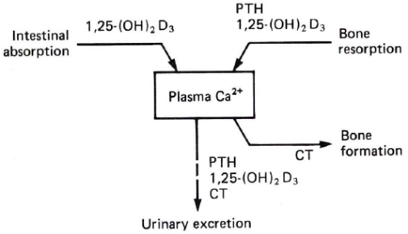
- Need vitamin D in combination with PTH to absorb Ca²⁺ from the intestine and Ca²⁺ from bone.
    - Steroid hormone and protein hormone modulate Ca²⁺ together in our circulation

- Modulation: intracellular receptors [steroid derived] in target organs

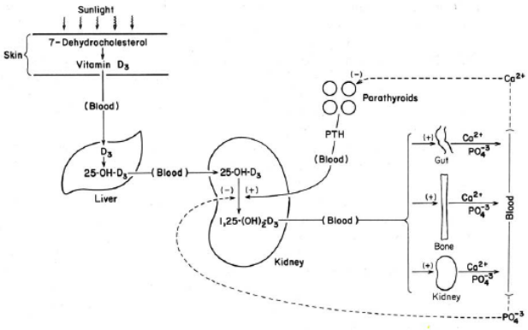
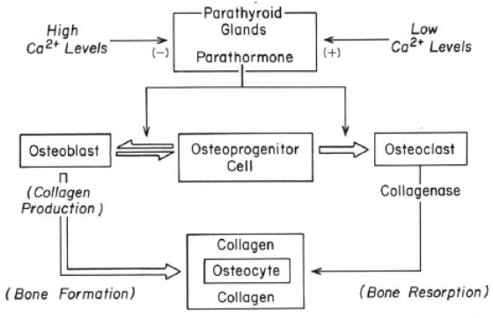
VITAMIN D3 AND PTH IN BONE
- Low Ca²⁺ triggers PTH to act on bone
    - Has kind of a stem cell → osteoprogenitor cell. This can give rise to an osteoblast (build up bone) or an osteoclast (break down bone)
- Osteoclast have collagenase activity. They digest collagen to release Ca²⁺ from osteocyte into the circulation
    - Bone is very well vascularized, so Ca²⁺ immediately enters
- Osteoblasts make bones with collagen around an osteocyte.
- Estrogen also has a role, as osteoclasts and osteoblasts both have estrogen receptors. However, it is not clear whether estrogen works by stimulating osteoclasts or inhibiting osteoblasts.
QUESTIONS
- Osteoporosis:
    - Younger women usually don’t get osteoporosis, but can happen for unknown reasons. There may be a genetic component
      - Entire osteoporosis process is not well understood.
    - Also, osteoporosis does not happen in men.
      - Apparently, the bone in men can handle absence of estrogen somehow
      - Means that androgens may promote bone formation
    - In post-menopausal women:
      - Lose both androgen and estrogen from theca and granulose cells, respectively
      - Adrenal gland provides some, but not enough
- Depraporvera: [birth control] and osteoporosis?
    - Apparently the drug could be implicated in osteoporosis
      - Other reports say its fine
    - Problem with studies involve that diversity of people being tested
      - Hard to figure out whether it is a direct effect of the drug or other issues [genetic, diet, race, etc]

- No long term proof that birth control inhibits menstrual cyclicity after you come off

